10.

(a)

library(ISLR)  
car=Carseats  
attach(car)  
pr=lm(Sales~Price+Urban+US)  
summary(pr)

##   
## Call:  
## lm(formula = Sales ~ Price + Urban + US)  
##   
## Residuals:  
## Min 1Q Median 3Q Max   
## -6.9206 -1.6220 -0.0564 1.5786 7.0581   
##   
## Coefficients:  
## Estimate Std. Error t value Pr(>|t|)   
## (Intercept) 13.043469 0.651012 20.036 < 2e-16 ***  
## Price -0.054459 0.005242 -10.389 < 2e-16 ***  
## UrbanYes -0.021916 0.271650 -0.081 0.936   
## USYes 1.200573 0.259042 4.635 4.86e-06 ***  
## ---  
## Signif. codes: 0 '***' 0.001 '**' 0.01 '*' 0.05 '.' 0.1 ' ' 1  
##   
## Residual standard error: 2.472 on 396 degrees of freedom  
## Multiple R-squared: 0.2393, Adjusted R-squared: 0.2335   
## F-statistic: 41.52 on 3 and 396 DF, p-value: < 2.2e-16

(b)

summary(car)

## Sales CompPrice Income Advertising   
## Min. : 0.000 Min. : 77 Min. : 21.00 Min. : 0.000   
## 1st Qu.: 5.390 1st Qu.:115 1st Qu.: 42.75 1st Qu.: 0.000   
## Median : 7.490 Median :125 Median : 69.00 Median : 5.000   
## Mean : 7.496 Mean :125 Mean : 68.66 Mean : 6.635   
## 3rd Qu.: 9.320 3rd Qu.:135 3rd Qu.: 91.00 3rd Qu.:12.000   
## Max. :16.270 Max. :175 Max. :120.00 Max. :29.000   
## Population Price ShelveLoc Age   
## Min. : 10.0 Min. : 24.0 Bad : 96 Min. :25.00   
## 1st Qu.:139.0 1st Qu.:100.0 Good : 85 1st Qu.:39.75   
## Median :272.0 Median :117.0 Medium:219 Median :54.50   
## Mean :264.8 Mean :115.8 Mean :53.32   
## 3rd Qu.:398.5 3rd Qu.:131.0 3rd Qu.:66.00   
## Max. :509.0 Max. :191.0 Max. :80.00   
## Education Urban US   
## Min. :10.0 No :118 No :142   
## 1st Qu.:12.0 Yes:282 Yes:258   
## Median :14.0   
## Mean :13.9   
## 3rd Qu.:16.0   
## Max. :18.0

Quantitative：Prices

Qualitative：USYes, UrbanYes.

(c)

$$Sales=13.04-0.05*Price-0.02*Urban+1.2*US$$

(d)

Price and US, because the p-value is small.

(e)

summary(n)

##   
## Call:  
## lm(formula = Sales ~ Price + US)  
##   
## Residuals:  
## Min 1Q Median 3Q Max   
## -6.9269 -1.6286 -0.0574 1.5766 7.0515   
##   
## Coefficients:  
## Estimate Std. Error t value Pr(>|t|)   
## (Intercept) 13.03079 0.63098 20.652 < 2e-16 ***  
## Price -0.05448 0.00523 -10.416 < 2e-16 ***  
## USYes 1.19964 0.25846 4.641 4.71e-06 ***  
## ---  
## Signif. codes: 0 '***' 0.001 '**' 0.01 '*' 0.05 '.' 0.1 ' ' 1  
##   
## Residual standard error: 2.469 on 397 degrees of freedom  
## Multiple R-squared: 0.2393, Adjusted R-squared: 0.2354   
## F-statistic: 62.43 on 2 and 397 DF, p-value: < 2.2e-16

(f)

The $R^{2 }$ of two models are small, so it don’t fit the data well.

(g)

confint(n)

## 2.5 % 97.5 %  
## (Intercept) 11.79032020 14.27126531  
## Price -0.06475984 -0.04419543  
## USYes 0.69151957 1.70776632

(h)

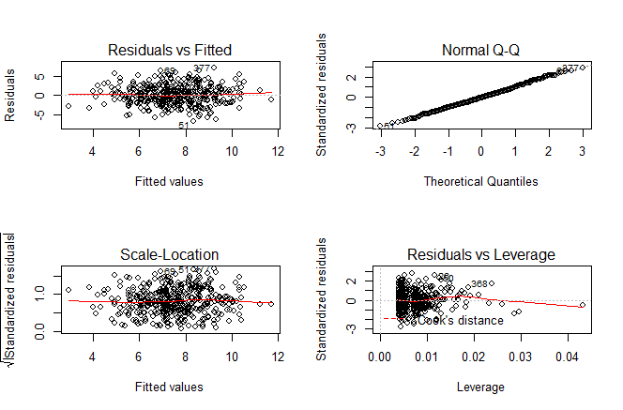

As we see in the figures, there are some high leverage points in the model.